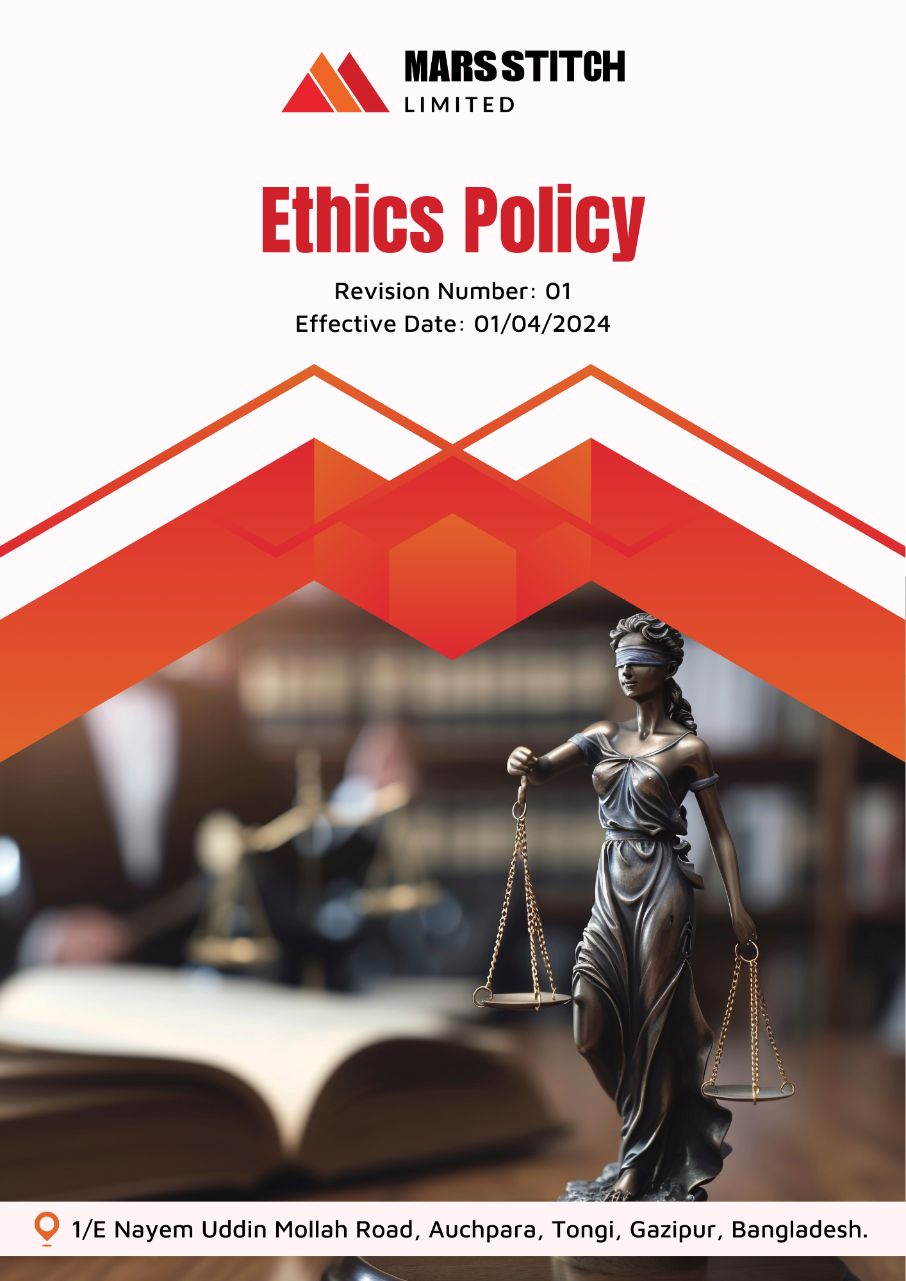

Policy Number

04313

Prepared by

Maria G. White

mariawhite@workerwrite.com
INDEX
⧫ INTRODUCTION 3
⧫ SCOPE 3
⧫ POLICY STATEMENT 3
⧫ KEY FOCUS AREA 4
⧫ QUALITATIVE TARGETS 4
⧫ QUANTITATIVE TARGET 6
⧫ THE ORGANIZATION OR PERSON RESPONSIBLE FOR IMPLEMENTING THE POLICY 7
⧫ CONTINUES IMPROVEMENT 8
⧫ REPORTING 8
⧫ DISCIPLINARY MEASURES FOR POLICY VIOLATIONS 9
⧫ REVIEW MECHANISM 9
⧫ EMPLOYEE ACKNOWLEDGEMENT FORM 10

- INTRODUCTION
Mars Stitch Ltd. is committed to fostering a culture of integrity and transparency in all aspects of our business operations. As a leader in the textile and garment industry, we uphold the highest ethical standards to ensure fairness, accountability, and trust among our employees, stakeholders, and communities. Our Ethics Policy outlines our commitment to ethical practices, promoting honest and responsible decision-making across the organization.

At Mars Stitch Ltd., we believe that ethical behavior forms the foundation of sustainable success. This policy serves as a guiding framework to address ethical dilemmas, prevent misconduct, and reinforce our values of integrity, respect, and responsibility. Together, we strive to create a work environment where ethical practices are celebrated, and accountability is paramount.
- SCOPE
This policy applies to all employees, workers, contractors, contractual worker, subcontractors, internal and external stakeholders associated with Mars Stitch Ltd. It covers every level of the organization, ensuring ethical practices in all activities, interactions, and transactions.

Sr. No. | Name of Site | Address
1 | Mars Stitch Ltd. | 1/E Nayem Uddin Mollah Road, Auchpara, Tongi, Gazipur, Bangladesh.
- POLICY STATEMENT
Mars Stitch Ltd. is dedicated to fostering a workplace rooted in ethical principles. By prioritizing transparency, accountability, and fairness, we aim to build trust with our stakeholders and positively impact the communities we serve. Through adherence to international ethical standards and robust internal policies, we are committed to setting a benchmark for ethical excellence in the textile industry.
- KEY FOCUS AREA
Mars Stitch Ltd. focuses on the following principles to uphold ethical standards:
- Transparency: Maintain clear, honest, and open communication with all stakeholders, and ensure accuracy in financial reporting and operational disclosures.
- Accountability: Hold employees and leaders accountable for actions and decisions, and establish clear protocols to address ethical violations promptly.
- Anti-Corruption Practices: Prohibit bribery and corruption, implement robust monitoring systems, and prevent conflicts of interest.
- Fair Treatment: Promote respect and equal opportunities, safeguarding the dignity of every individual.
- Whistleblower Protection: Ensure anonymity and protection for whistleblowers while addressing all reported issues promptly.
- Conflict of Interest: Establish guidelines to prevent and manage conflicts of interest, ensuring decisions are made in the best interests of the company and stakeholders.
- Fraud: Implement stringent measures to detect and prevent fraudulent activities, including regular audits and secure reporting mechanisms.
- Money Laundering: Ensure compliance with anti-money laundering regulations by monitoring financial transactions and reporting suspicious activities to relevant authorities.
- Information Security: Protect sensitive company and stakeholder data through advanced security protocols, regular assessments, and employee training.
- QUALITATIVE TARGETS
Transparency:
- Provide quarterly updates on company performance and initiatives to stakeholders.
- Conduct annual training sessions on ethical communication for employees.
Accountability:
- Establish an ethics committee to oversee compliance and address ethical concerns.
- Develop a reporting system to track and resolve ethical violations within 30 days.
- Hold monthly reviews to identify and address lapses in ethical behaviour.
Anti-Corruption Practices:
- Conduct annual audits to identify and eliminate potential corruption risks.
- Monitor financial transactions monthly to detect and prevent corrupt activities.
- Enforce disciplinary action against confirmed cases of corruption within 30 days.
- Implement training programs to educate employees on recognizing and preventing corruption.
Fair Treatment:
- Implement diversity and inclusion programs to ensure equal opportunities.
- Resolve grievances related to unfair treatment within 15 days of filing.
- Conduct sensitivity training to foster respect and understanding among employees.
- Regularly assess hiring and promotion processes to eliminate bias.
Whistleblower Protection:
- Launch an anonymous whistleblower hotline accessible to all employees.
- Investigate 100% of reported cases within 45 days.
- Provide training on the importance of whistleblowing and protection measures.
Conflict of Interest:
- Require all employees to disclose potential conflicts of interest annually.
- Conduct annual assessments of high-risk roles for potential conflicts.
- Educate employees on recognizing and avoiding conflicts of interest through regular workshops.
Fraud:
- Perform annually financial audits to detect and prevent fraudulent activities.
- Develop robust internal controls to minimize opportunities for fraud.
- Provide whistleblower mechanisms specifically for reporting fraud.
- Train employees on identifying red flags associated with fraudulent behaviour.
Money Laundering:
- Train finance and compliance teams on AML protocols annually.
- Monitor all large financial transactions for suspicious activity.
- Collaborate with financial institutions to strengthen AML compliance.
Information Security:
- Conduct regular risk assessments to identify and mitigate data security threats.
- Provide mandatory cybersecurity training for all employees annually.
- Implement multi-layered security measures to protect sensitive data.
- Establish rapid response protocols for addressing data breaches effectively
- QUANTITATIVE TARGET
Mars Stitch Ltd. has set measurable targets to reinforce ethical practices, with 2023 as the baseline year.
Anti-Corruption Practices:
- Perform annual audits of 100% of financial records to prevent corruption by 2026.
- Maintain zero confirmed corruption cases by 2026 through training and monitoring.
- Train 100% of employees annually on anti-corruption practices by 2026.
- Conduct annually monitoring of 100% of financial transactions to detect corruption risks by 2026.
Fair Treatment:
- Implement diversity programs to increase representation of underrepresented groups by 10% by 2026.
- Conduct sensitivity training for 100% of employees annually by 2026.
Whistleblower Protection:
- Investigate 95% of whistleblower reports within 45 days by 2026.
- Increase whistleblower participation by 20% annually through improved reporting systems by 2026.
- Train 100% of employees on whistleblower protection protocols annually by 2026.
Conflict of Interest:
- Require 100% of employees to submit conflict of interest disclosures annually by 2026.
- Review 100% of high-risk roles quarterly for potential conflicts by 2026.
- Conduct conflict of interest resolution training for 100% of managers by 2026.
Fraud:
- Perform annually financial audits to detect fraudulent activities across all departments by 2026.
- Train 100% of employees annually on identifying and reporting fraudulent behaviors by 2026.
- Resolve fraud reports within 30 days of detection by 2026.
Money Laundering:
- Train 100% of finance and compliance teams annually on AML protocols by 2026.
- Monitor all financial transactions above 10,000 for suspicious activity by 2026.
- Ensure 100% compliance with AML regulations by 2026 through rigorous monitoring.
Information Security:
- Conduct annual cybersecurity assessments to address potential vulnerabilities by 2026.
- Train 100% of employees annually on cybersecurity best practices by 2026.
- Reduce data breach risks by 20% annually through enhanced security protocols by 2026.
- THE ORGANIZATION OR PERSON RESPONSIBLE FOR IMPLEMENTING THE POLICY
Mars Stitch Ltd. has designated a dedicated committee to ensure the successful implementation of this policy. This committee is responsible for monitoring, reviewing, and enforcing the policy while maintaining compliance with internal and external standards.
Sr. No. | Name | Designation | Committee Designation
1. | S.M Azmal Huda | General Manager(Operation) | President
2. | Mahmodul Hasan | Manager – HR, Admin & Com. | Vice President
3. | Eva Akter | Executive-Welfare | Member Secretary
4. | Nonda Gopal | Sr. Executive -Compliance | Member
5. | Md.Shanta | Maintenance In-charge | Member
6. | Md. Masud | Asst. Manager-Admin | Member
7. | Mr. Antar | Asst. Manager-Store | Member
8. | Md. Samim | Cutting Asst. | Member
9. | Md. Nayeem Hosan | Quality Inspector | Member
10. | Mst. Ruma Akter | Operator(Sewing) | Member
11. | Mst. Jushna Begam | Operator(Sewing) | Member
12. | Mst. Mira | Finishing Asst. | Member
- CONTINUES IMPROVEMENT
Mars Stitch Ltd. is committed to continuous improvement in ethical practices through:
- Regular reviews of the Ethics Policy to align with evolving standards and stakeholder expectations.
- Establishing partnerships with ethical organizations to promote best practices.
- Encouraging feedback from employees and stakeholders to identify areas for enhancement.
- Monitoring ethical performance through key performance indicators (KPIs).
- REPORTING
To ensure transparency and accountability:
- Annual Review: Publish an annual Ethics Report detailing compliance, progress, and future goals.
- Stakeholder Communication: Provide regular updates on ethical initiatives through newsletters and meetings.
- Incident Reporting: Maintain a secure system for reporting and addressing ethical violations.
- DISCIPLINARY MEASURES FOR POLICY VIOLATIONS
Mars Stitch Ltd. enforces strict disciplinary measures for violations of the Ethics Policy to uphold integrity and accountability across all levels of the organization. Any employee found in breach of this policy will face consequences proportional to the severity of the violation, which may include:
- Verbal or written warnings for minor infractions.
- Suspension or demotion for serious or repeated violations.
- Immediate termination of employment in cases of gross misconduct, such as fraud, corruption, or willful negligence.

Additionally, incidents involving external stakeholders, such as suppliers or contractors, will result in termination of contracts and potential legal actions as per applicable laws. Mars Stitch Ltd. ensures that all disciplinary actions are conducted fairly, transparently, and in compliance with legal and regulatory requirements.
- REVIEW MECHANISM
This policy will be reviewed annually by the Sr. Executive -Compliance to ensure its effectiveness and alignment with industry standards. Revisions will incorporate stakeholder feedback and evolving ethical expectations.

Prepared By : Sr. Executive -Compliance Approved By : General Manager
Next Review Date : 01/04/2025
- EMPLOYEE ACKNOWLEDGEMENT FORM
By signing this form, employees acknowledge their understanding of and commitment to Mars Stitch Ltd.'s Ethics Policy. Compliance with the policy is a shared responsibility and a key part of our collective effort to uphold ethical practices and integrity.

Employees agree to actively support and implement the principles outlined in this policy. This includes participating in ethics training, adhering to company standards, and reporting any unethical behaviour promptly. Employees also recognize their role in fostering a transparent and responsible workplace.

Employee Name:

Designation:

Signature:

Date:

